ELECTRIC SCOOTER – device weighing less than 100lbs. with handlebars and electric motor, powered solely by motor and human power. max speed: 20mph
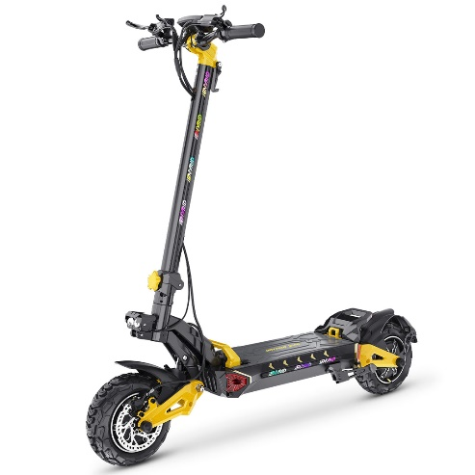

MOTOR BICYCLE – a bicycle which a power unit that is not an integral part of the vehicle and has been added to permit the vehicle to travel at a speed of not more than 30mph with a 150lb rider. motor bicycle does not include an electric bicycle.

MOTORCYCLE – a motor vehicle originally manufactured with motive power, a seat or saddle requiring the rider to sit, not more than 3 wheels, steering controlled by handlebars, and acceleration and braking controlled with handlebar and foot controls and capable of speeds in excess of 30 mph.

ELECTRIC BICYCLE – means a bicycle equipped with fully operative pedals by human power and electric motor of 750 watts or less
- class 1: motor (provides assistance) only when rider is pedaling and ceases to provide assistance when reaches speeds of 20mph
- class 2: powered solely by the motor and not capable of providing assistance when reaching speeds of 20mph
- class 3: motor that provides assistance only when the rider is pedaling and ceases to provide assistance with speeds of 28mph.
****(anything in excess of 30mph is considered a motorcycle and must be registered and equipped as such!) ********

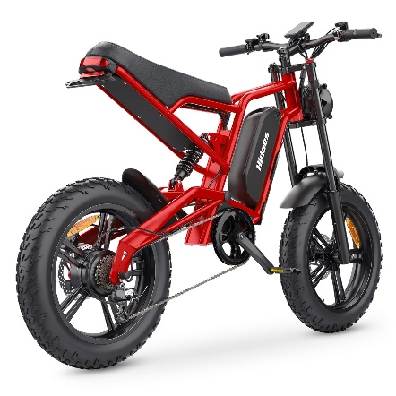

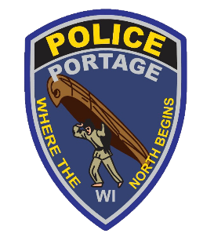

CLASSIFICATIONS AND DEFINITIONS

Portage Police Department
117 W. Pleasant St.
Portage, WI 53901
608-742-2174

346.80 RIDING BICYCLE, ELECTRIC SCOOTER… ON ROADWAY.
(2) (a) Less than the normal speed of traffic shall ride to the right-hand edge or curb of the unobstructed traveled roadway… except:
1. When overtaking and passing another vehicle proceeding in the same direction.
2. When preparing for a left turn
3. When reasonably necessary to avoid unsafe conditions, including fixed or moving objects, parked or moving vehicles, pedestrians, animals.
b.) On a one-way road, ride on the left side closest to the curb as practicable.
c.) Allow 3 ft. of space between vehicles.
3(a) can ride side by side if it does not impede normal and reasonable movement of traffic.
b.) Cannot ride more than 2 side by side.
4. Cannot operate on roadway where sign indicates prohibited.
5. Every rider shall, upon entering the road, yield the right of way to motor vehicles.

WISCONSIN
STATE
STATUTES

346.804 RIDING BICYCLE ON SIDEWALK
Every person operating a bicycle upon a sidewalk shall yield the right of way to any pedestrian and give audible signal when passing anyone on sidewalk in same direction.

346.805 RIDING ELECTRIC SCOOTER… ON SIDEWALK.
A person may operate an electric scooter upon any sidewalk and shall yield the right of way to any pedestrian or bicyclist and shall exercise due care and give audible signal when passing anyone on sidewalk in the same direction.

346.806 SPECIAL RULES APPLICABLE TO ELECTRIC BICYCLES.
1.) An electric bicycle shall be considered a vehicle to the same extent as a bicycle.
2.) A person operating an electric bicycle is not subject to operators’ licenses, registration.
3.) A person may ride with the power unit in operating, an e-bike upon a bikeway.
4.) No person under the age of 16 yrs. may operate a class 3 e-bike. A person under the age of 16 yrs. may ride as a passenger on a class 3 e-bike designed to accommodate passengers.



